  - Create a drawing that uses one or two point perspective. You must include at least 5 shapes (can be geometric, abstract, letters, etc.) and a line element that unifies all of the shapes. Your overall drawing should have one coherent theme. See examples below.
  - You will be assessed on the accuracy of the perspective. If it is not done correctly, you will lose points.
  - Sketchbook Assignment #9: Use the worksheet below to copy the shapes in your sketchbook. Draw each shape in correct one-point perspective using the vanishing point in the center (each shape should connect to the same vanishing point). There are correct answers for this, so in order to get all 10 points, each shape should be drawn correctly!
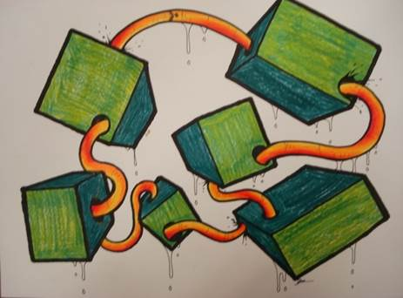
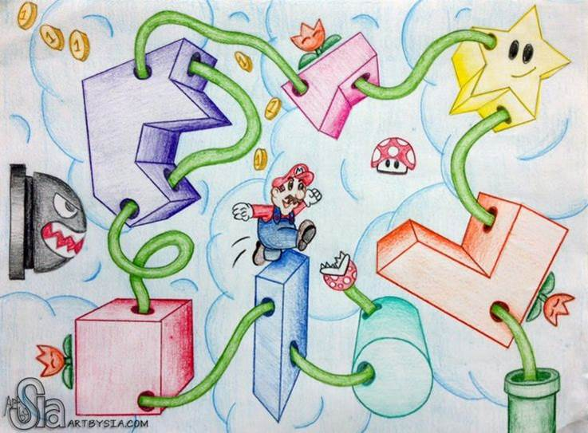
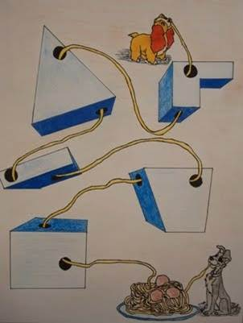
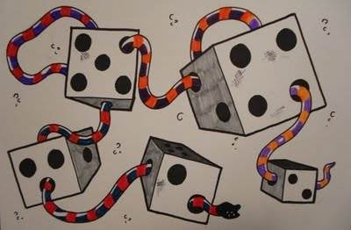
Unit Project Examples

