You will be creating a Creative Color Wheel painting. Design an image that incorporates the color wheel (though it does not need to be in a “wheel” format—this is open to interpretation).
Project Requirements:
- You must show a rough sketch of your idea prior to beginning on the project.
- All primary, secondary, and tertiary colors must be present in the final design.
- You will be using acrylic paint. Wear clothes that won’t be the end of the world if you get paint on them (I have scrubs you can use to cover up with, but accidents still happen).
- You will be responsible for mixing all of the colors you need. I will only provide the primary colors, black, and white.
- I will provide paper to use for the final painting. However, if you would prefer to paint on a canvas or canvas panel, you will need to purchase one and bring it to class.
Project Due Date/In-class Critique: Thursday, September 17th, 2015
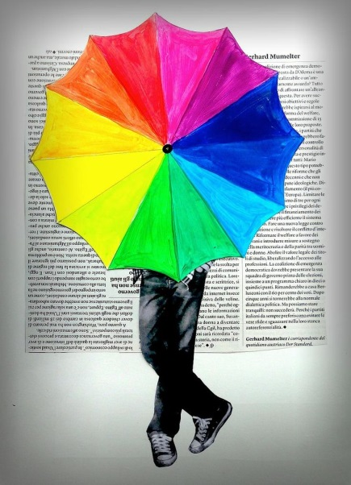
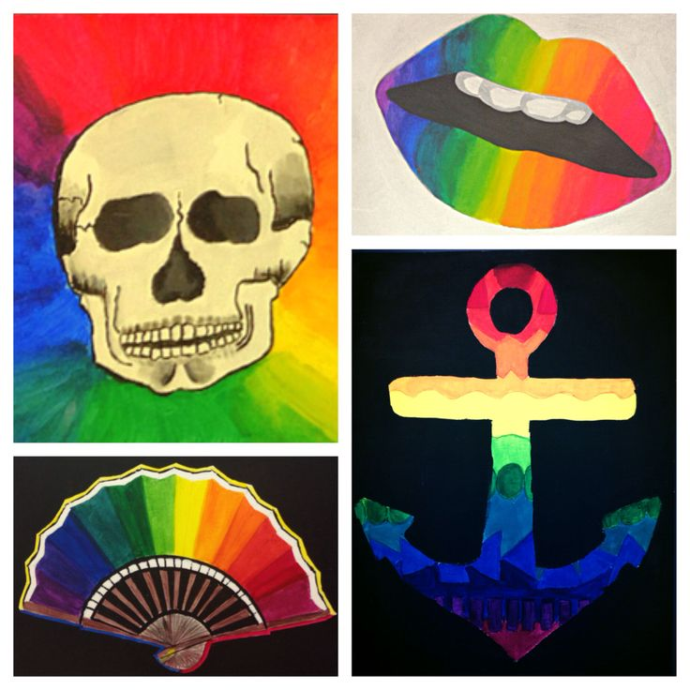
Project Examples

